**Outcomes**

**Murder**

**Assault**

Motor vehicle

**Burglary**

**Specification**

All pre-treatment

All even

All second half

For our evidence, ideally we would have this:

1. Figures
   1. Main synth picture
   2. Event study picture
   3. Placebo picture
   4. Histogram picture showing p-value.
2. Table
   1. Weights of who is the synthetic control
   2. Balance table of covariates we used for matching
3. Estimated ATT with a p-value

**Results**

1. **Murder rate** estimated ATT:
   1. **All** pre-treatment specification:
      1. **-4.095** fewer murders per 100,000 (p=0.108)
      2. Pre-treatment RMSPE is 0.94
   2. Only pre-treatment **even** specification:
      1. **-3.661** fewer murders per 100,000 (p=0.043)
      2. Pre-treatment RMSPE is 0.94
   3. Only the second half, all pre-treatment specification:
      1. **-3.736** fewer murders per 100,00 (p=0.022)
      2. Pre-treatment RMSPE is 1.07

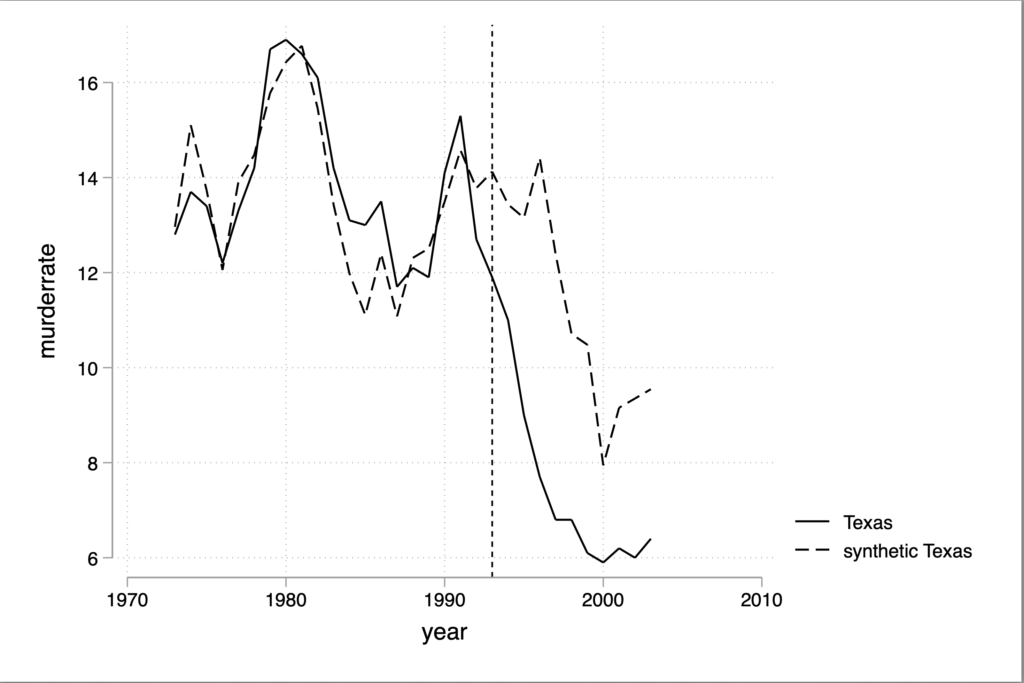

I can’t stop noticing that synth Texas does eventually fall. I don’t know if that matters but I can’t stop thinking about it because of the assault analysis later.

**Burglary rate** estimated ATT:

* 1. **All** pre-treatment specification:
     1. **-237** fewer burglaries per 100,000 (p=0.543)
     2. Pre-treatment RMSPE is 133.09
  2. Only pre-treatment **even** specification:
     1. **-248** fewer burglaries per 100,000 (p=0.478)
     2. Pre-treatment RMSPE is 136
  3. Only the second half, all pre-treatment specification:
     1. **-239** fewer burglaries per 100,00 (p=0.326)
     2. Pre-treatment RMSPE is 168

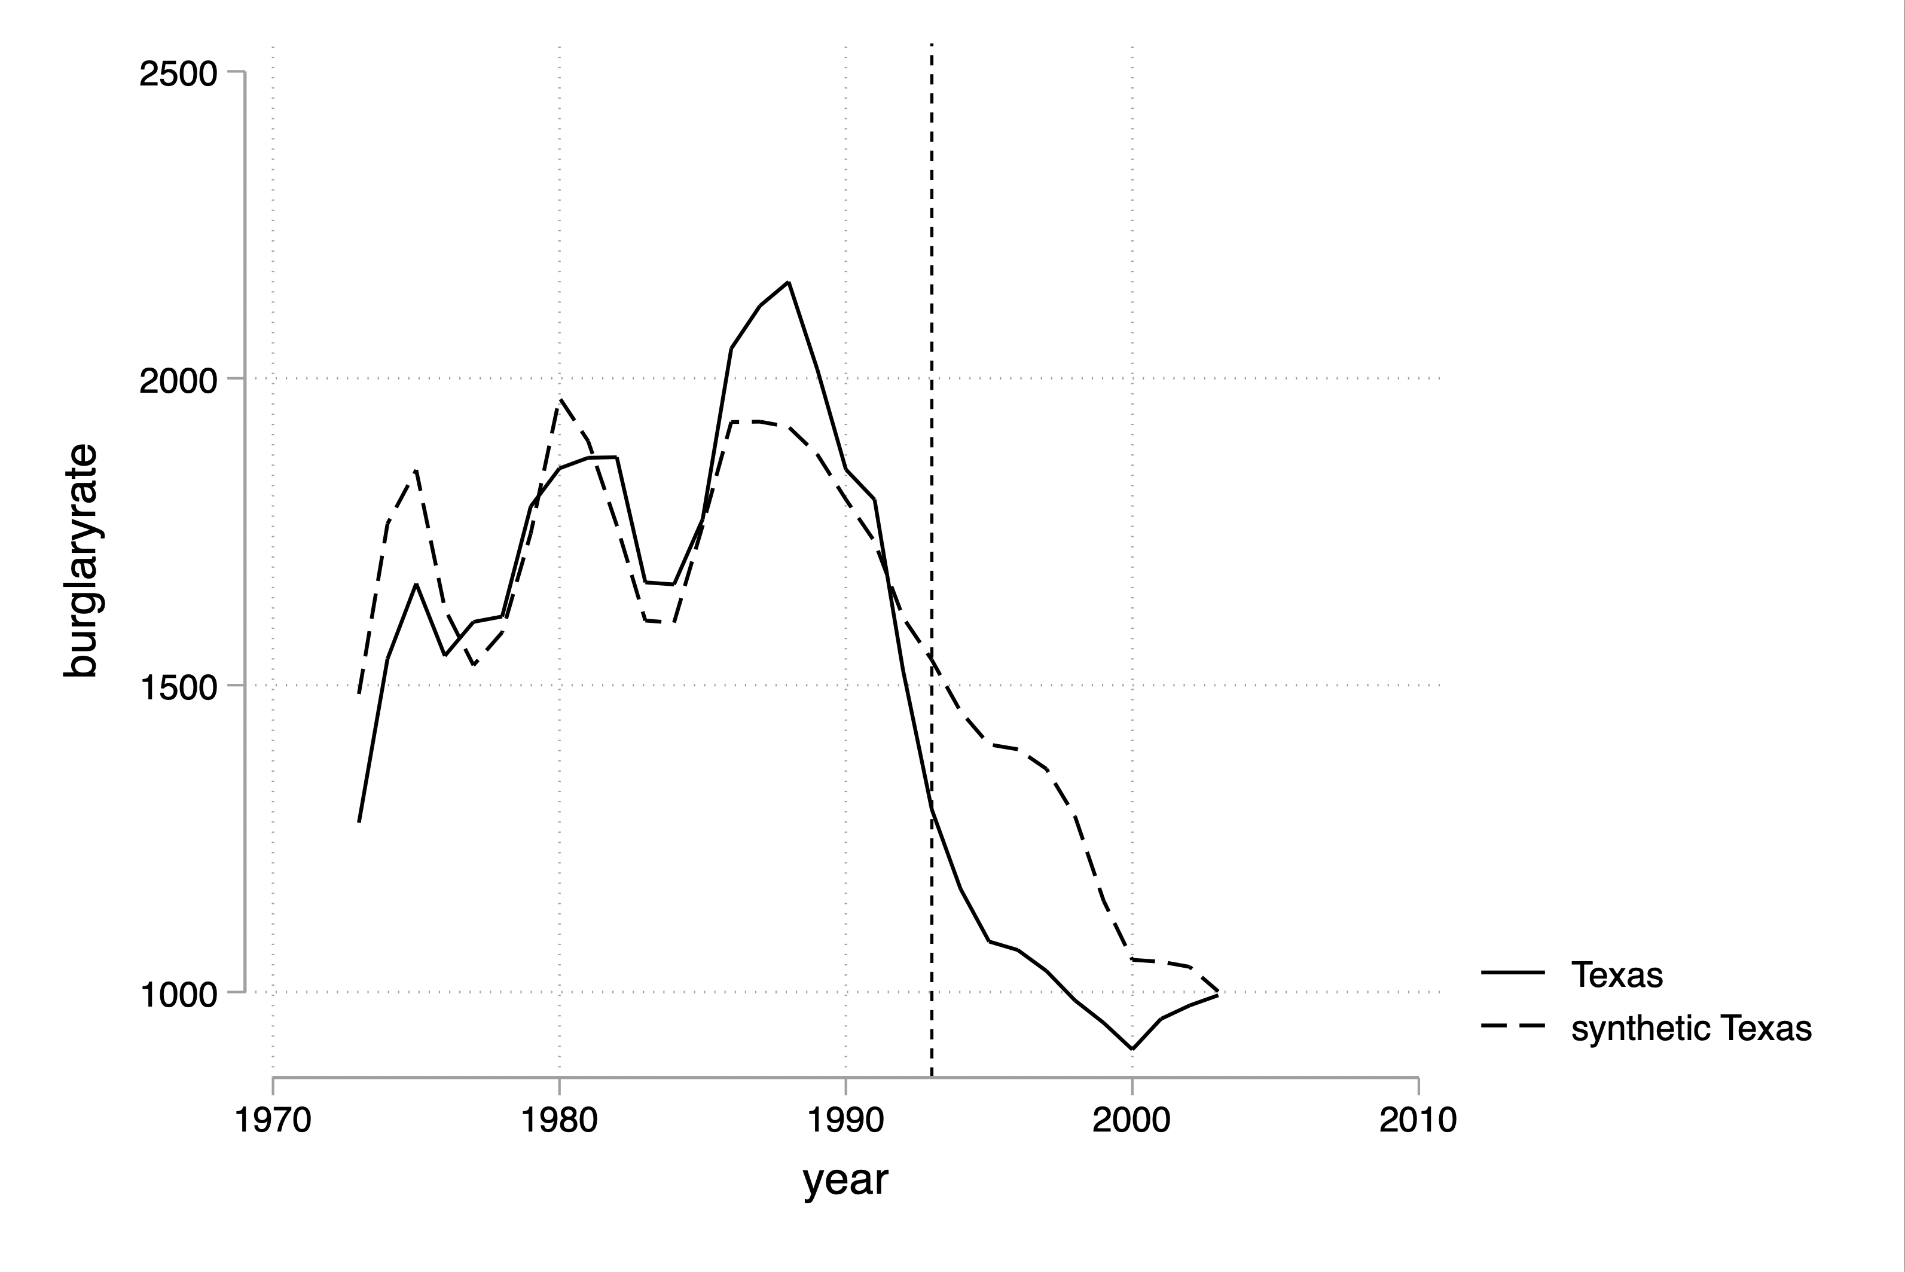**Assault rate** estimated ATT:

* 1. **All** pre-treatment specification:
     1. **+21.485** fewer assaults per 100,000 (p=0.696)
     2. Pre-treatment RMSPE is 10.47
  2. Only pre-treatment **even** specification:
     1. **-15.903** fewer assaults per 100,000 (p=0.804)
     2. Pre-treatment RMSPE is 12.335
  3. Only the second half, all pre-treatment specification:
     1. **+28.116** fewer assaults per 100,00 (p=0.783)
     2. Pre-treatment RMSPE is 24.062

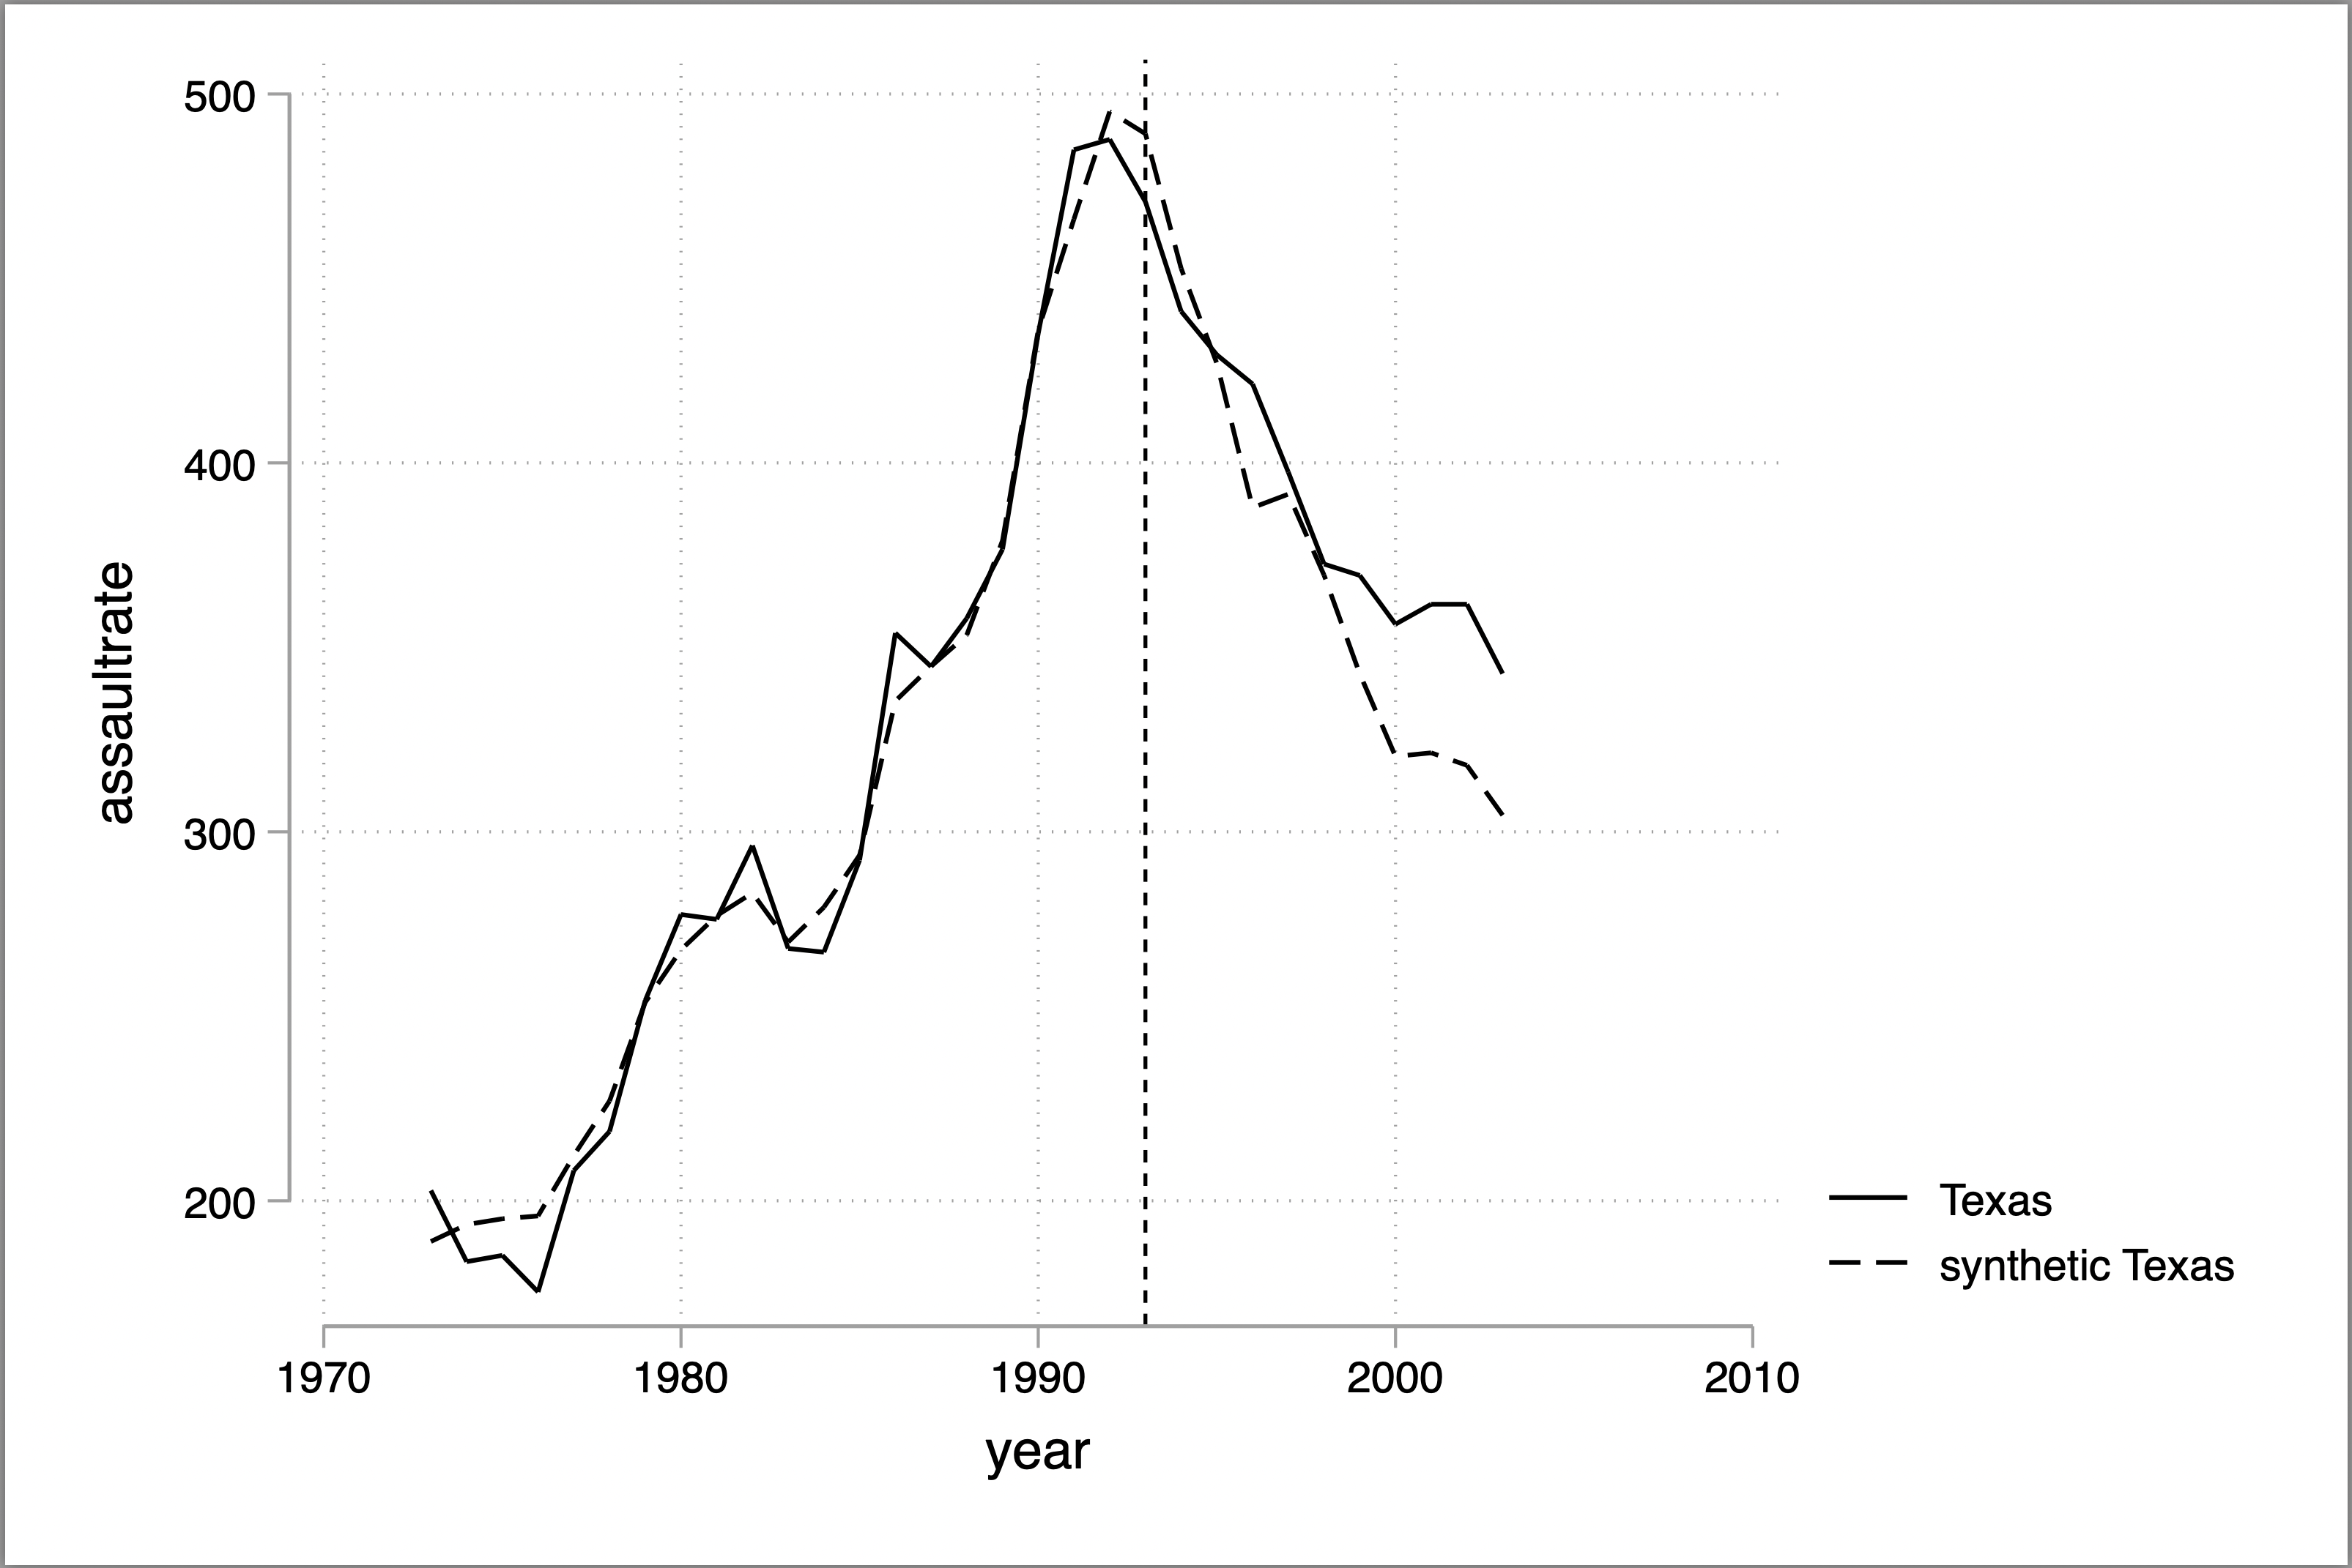

1. **Motor vehicle theft rate** estimated ATT:
   1. **All** pre-treatment specification:
      1. **-188.718** fewer vehicle thefts per 100,000 (p=0.457)
      2. Pre-treatment RMSPE is 43.855
   2. Only pre-treatment **even** specification:
      1. **-194.226** fewer vehicle thefts per 100,000 (p=0.304)
      2. Pre-treatment RMSPE is 44.379
   3. Only the second half, all pre-treatment specification:
      1. **-196.066** fewer vehicle thefts per 100,00 (p=0.783)
      2. Pre-treatment RMSPE is 68.548

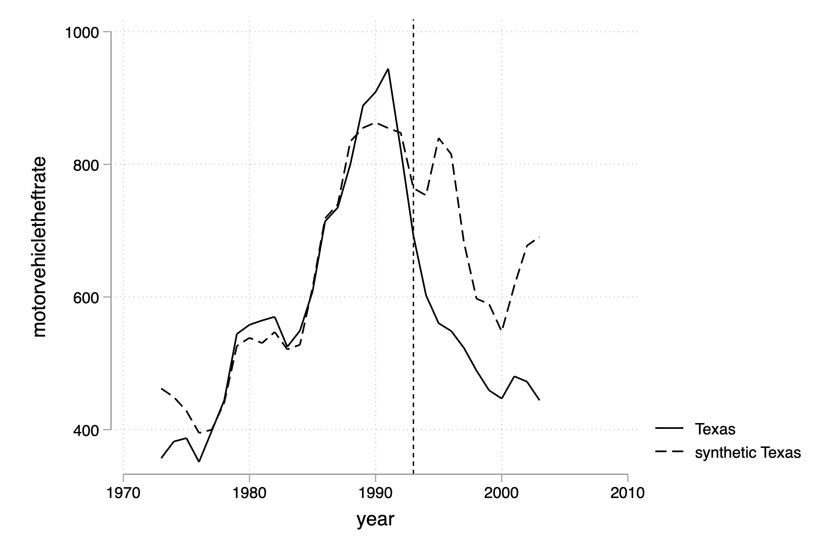

The murder results have several characteristics worth noting. First, the p-values are usually below 0.05, and even in the full model, it’s close to 0.10. But (not shown) it’s also the case that if I use the **size** of the treatment effect, as opposed to the **scaled size**, the effects gets stronger. And this is a pattern that we see carry over into burglaries.

But the effect for assaults worry me somewhat. Notice how the expansion of prisons happens at literally the peak of the assault rate rise. From 1970 until 1992, assaults had risen in Texas. They then peak and begin plummeting – but so does everywhere else. So even putting aside any estimated gap that I estimate after the prison expansion, I am concerned that the synthetic Texas experiences this plummeting of assaults in 1992 because now I’m realizing that the prison expansion happens at precisely the point when the US might be seeing its crime rates fall.

I don’t see the same extreme plummeting of car thefts in the data the way assaults made me feel. But you do see it.

**Discussion**

Let’s review the evidence together outcome by outcome and let’s vote. Secret ballot sent to me via chat. On a scale of 1 to 5, how convinced are you of a causal effect? 5 being “nearly certain”, and 1 being “strongly skeptical of a causal effect”.